Traffic Lights System

Project plan

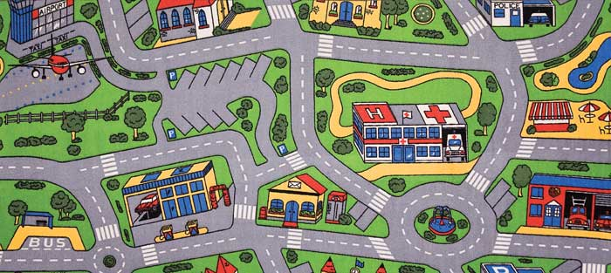

Table of Contents

Formal client 2

Project leader 2

Current situation 2

Project justification 2

Project Product 3

Deliverables 3

Non Deliverables: 3

Project Constraints 3

Project Risks 4

Project Phasing 5

Phases 5

Milestones 6

MOSQUITO 7

Quality 7

Time 8

Organisation 8

# Formal client

The formal client of Traffic Lights System project is Mr. George, the mayor of Csharp city. His main goal is to make the city a nice, pleasant and safe place to live.

# Project leader

The project leader is Bilger Yahov. Currently a second year student at Fontys University of Applied Sciences in Eindhoven. He is enthusiastic and shares Mr. George's idea of safety regulations.

# Current situation

Csharp is a small village with about 3000 residents. It is located between major cities that makes it a major crossing point. The situation with the traffic is not improving and there have been many car accidents. Mr. George wants those accidents to be prevented by placing traffic lights, which regulate the flow of the traffic. He is uncertain of the outcome, so he has come up with the idea of a traffic simulator that would allow him to see how successful his idea can become.

# Project justification

It is important to preserve human lives, so - traffic incidents must be avoided. This software will provide with the necessary tools to regulate the traffic within Csharp city to prevent traffic accidents. By having control over the traffic system the mayor’s desire of safe city will be satisfied.

# Project Product

We will deliver a working traffic stimulation program that can simulate different traffic situations within the city. The simulations can be adjusted for different scenarios and will provide with accurate results that can be related to real life.

# Deliverables

* Project plan
* User Requirements Specification
* Design document
* Test plan
* Simulation application
* Simulation application documentation (User manual)
* Tests outcome
* Presentation on the product with a demo

# Non Deliverables:

* Training of people how to use the software application
* Hardware supplies
* Maintenance of the product

# Project Constraints

**Programming language**

The programming language for developing the project will be C#

**Operating system**

The project will be compatible with Windows Operating System that supports the .NET 3.0+ Framework.

**Time**

There are approximately 15 weeks for the project and documentation to be finished

# Project Risks

|  |  |  |  |  |
| --- | --- | --- | --- | --- |
| Risk | Probability | Impact | Risk Prevention | Solution |
| Falling behind on work schedule | Medium | High | Communication is key. Keep track of each person’s situation and work load to make sure it can be handled. | Reassign all the tasks to other group members. The people that have the least work will get the most. |
| Breakdown in communication with client | Low | High | Keep the client informed and involved with the project | The project group will work with the information they currently have and think about what’s best for the project |
| Sudden request of requirements or features from the client | Medium | Medium | Try to get every bit of information from the client and what he wants as early as possible and agree on a final list of deliverables. | If time allows make changes to the project and adapt to fulfill the newly requested features. |
| Team members dropping out | Low | High | Keep the project leader informed so steps to avoid this can be taken in time. | Redistribute all the remaining tasks or seek to replace the person. |

# Project Phasing

## Phases



## Milestones

|  |  |  |
| --- | --- | --- |
| Deliverables | | |
| Milestone 1 | * Project plan * User Requirements Specification document first version | 04.03.2016 |
| Milestone 2 | * Test Plan * Design document * GUI design | 01.04.2016 |
| Milestone 3 | * Prototype first version | 20.05.2016 |
| Milestone 4 | * Prototype final version * User manual * Final report – first version | 12.06.2016 |
| Milestone 5 | * Deploy the source code * Present the application * Final report – final version | 19.06.2016 |

# MOSQUITO

## Quality

Quality means that the application created by the project group is **stable**, **easy to use** and offer the **best experience** to the client. To assure this:

**Code quality:**

* Making tests for the application behavior.
* Making a standard for writing the code (picking convention).
* Using Git to monitor and easily update the file versions (with messages to know what has changed).
* Making tests for the execution of the code.

**Usability:**

* Making the user interface **easy to navigate** through (also intuitive).
* Offer simple steps of progress, with not too much information, so the user does not get confused.

**Stability:**

* For the application to be **stable** the project group will debug and test for every user input.
* Error handling will be present, to make sure if any errors occur the user knows what is happening or what he has done wrong.
* Unexpected crashing of the application will be prevented by controlling the behavior of the errors.

## Time

1. It is estimated that this project will last 5 months.  
   The project starts on 17**th of February** and the final product will be presented somewhere in the end of June**.**
2. Time planning for project activities is as follows:
   1. Make the project plan 2 weeks
   2. Make URS 1.5 week
   3. Make Design Document 1.5 week
   4. Create application 6-7 weeks
   5. Tests outcome document 1 week
   6. Create User manual 3 days
   7. Prototype presentation 1 day
   8. Making further changes if needed 3 days
   9. Final presentation 1 day

## Organisation

E:\BrowserDownloads\Untitled Diagram.png

* Bilger Yahov - Project Leader - 2442450 - 7s1
* Oleksandr Suprunenko - Chairman - 2524449 - 7s1
* Ilia Nikushev - Quality Manager - 2551721 - 7s1
* Georgi Chishirkov - Keeping track of Agendas - 2530090 - 7s1
* Lyubomir Dimov - Notes taker - 2431424 - 7s2
* Mengchuan Liu - The only girl in the group - 2151655 - 7s1